Sql Dump Split

1.Connection to instance using ssh.

2.wget the sqldump file from s3 bucket

3. Gunzip 1tokingaws-23Sep2017_063001.sql.gz

Extracting user...

**1 Table extracted from 1tokingaws-23Sep2017_063001.sql at .**

4.**Connect to the instance using filezilla and upload mysqldumpsplitter.sh file to /mnt/demo**

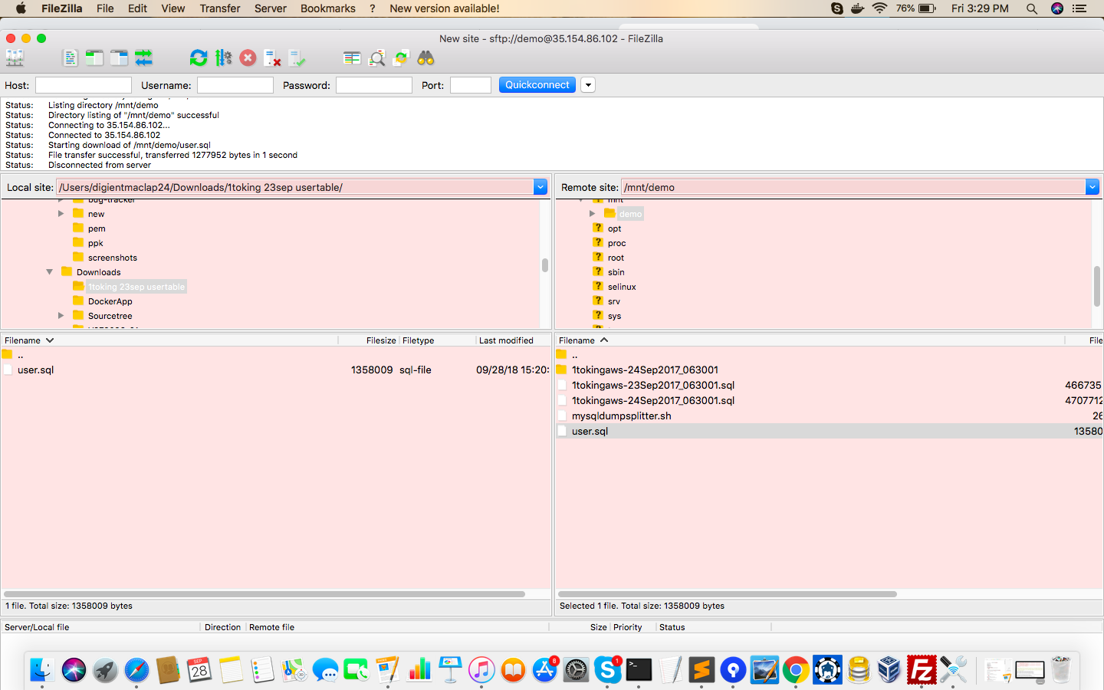

**5.Allowing executing access to mysqldumpsplitter.sh:**

chmod +x to mysqldumpsplitter.sh

6.Running the shell script :

demo@ip-172-31-26-28 demo]$ ./mysqldumpsplitter.sh 1tokingaws-23Sep2017_063001.sql user

Extracting user...

**1 Table extracted from 1tokingaws-23Sep2017_063001.sql at .**

**7.The file is created in the location**

